Assignment 6 Abhishek Nikam

**PCI-Express Bandwidth with page-lock memory**

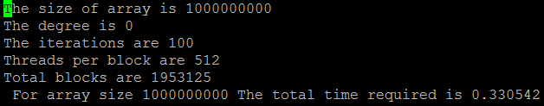

So the bandwidth observed is 12.2 GB/s.